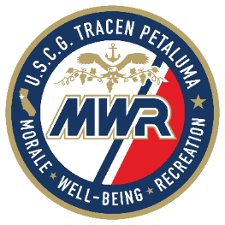

Full Time Positions Currently Open:
(35-40 hours per week)
Recreation Aid 3673
Location: Youth Services/Teen center

Part Time Positions Currently Open:
(20-29 hours per week)
Food and Beverage Attendant 3562
Location: Two Rock Pizza/Coffee Shop
Desk Clerk 3672
Location: Guest Lodging

Intermittent On-Call Positions Currently Open:
(0-19 hours per week)

Cook 3361
Location: Two Rock Pizza
Child Care Assistant 3356
Location: Child Development Center
Bartender 3360
Location: Consolidated Club
Life Guard 3358
Location: Aquatic Center
Food and Beverage Attendant 3563
Location: Two Rock Pizza/Coffee Shop

To apply go to:

www.shopcgx.com
*Scroll to the bottom click careers *
As of 09/17/2020

